Project Design Phase-II
Data Flow Diagram & User Stories

Date | 31 January 2025
Team ID
Project Name | Import Data using Transform Maps (Spreadsheet)
Maximum Marks | 4 Marks

Data Flow Diagrams:
A Data Flow Diagram (DFD) is a traditional visual representation of the information flows within a system. A neat and clear DFD can depict the right amount of the system requirement graphically. It shows how data enters and leaves the system, what changes the information, and where data is stored.
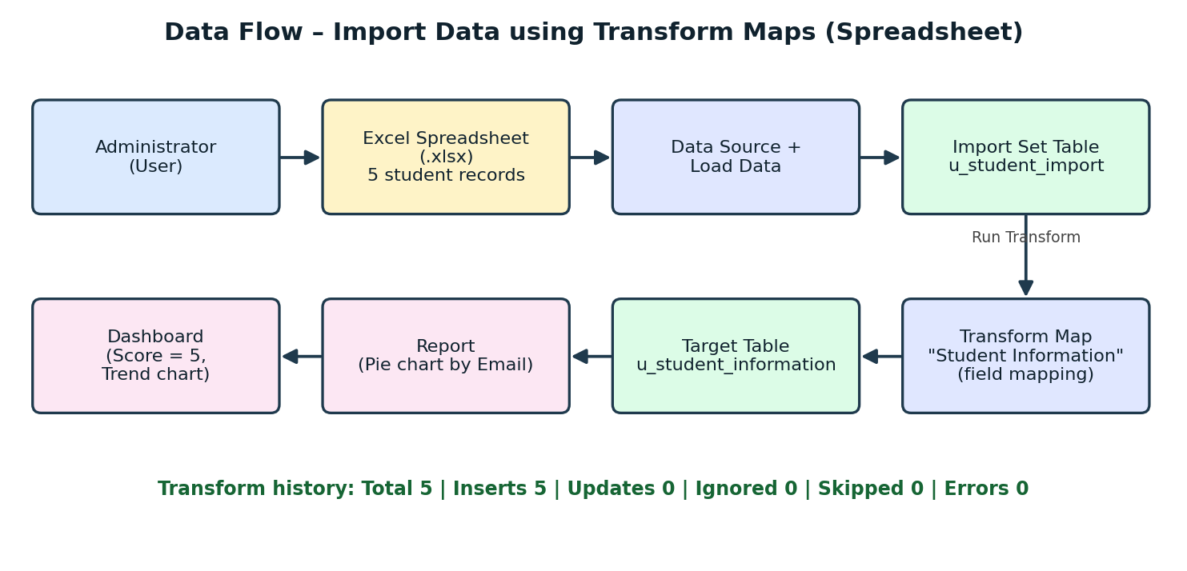
Figure 1: Data flow diagram – Import Data using Transform Maps (Spreadsheet)

User Stories
Use the below template to list all the user stories for the product.
User Type | Functional Requirement (Epic) | User Story Number | User Story / Task | Acceptance criteria | Priority | Release
Administrator | Data Preparation | USN-1 | As an administrator, I can prepare a spreadsheet with Student ID, Student Name, Department, Email and Year. | Spreadsheet with 5 student records is ready | High | Sprint-1
 | Table Creation | USN-2 | As an administrator, I can create the "Student Information" table with the required columns. | Table shows Student ID, Name, Department, Email, Year columns | High | Sprint-1
 | Data Import | USN-3 | As an administrator, I can load the spreadsheet into the import set table u_student_import. | 5 rows appear in the import set table | High | Sprint-1
 |  | USN-4 | As an administrator, I can create a Transform Map that maps import fields to the Student Information table. | All 5 fields are mapped to target fields | High | Sprint-1
 | Data Transformation | USN-5 | As an administrator, I can run the transform and check the results. | Transform History shows Complete, 5 inserts, 0 errors | High | Sprint-2
Data Analyst / Faculty | Reporting | USN-6 | As a user, I can view a pie chart report of the imported student records. | Report shows 5 records (20% each) grouped by Email | Medium | Sprint-2
 | Dashboard | USN-7 | As a user, I can view a dashboard with the total record count and a trend chart. | Dashboard shows score 5 and line chart | Medium | Sprint-2

